 | Term 1 | Term 2 | Term 3 | Term 4 | Term 5 | Term 6
Reception | Look at me  Autumn  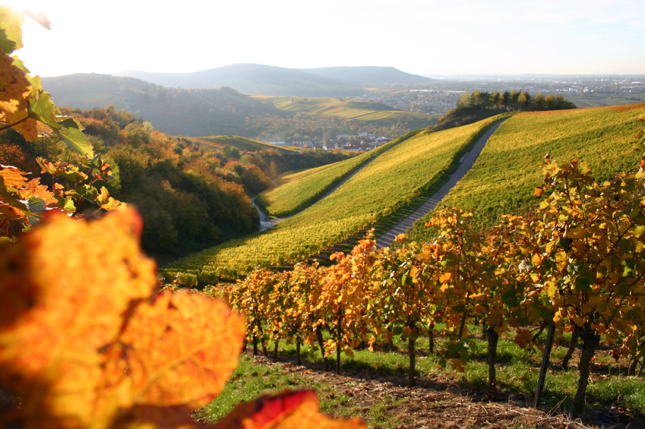 | Family Fun   | Tell me a story    Superheroes & Space | How big is big?  100 Centenary | What’s in the garden? | Let’s go to the beach  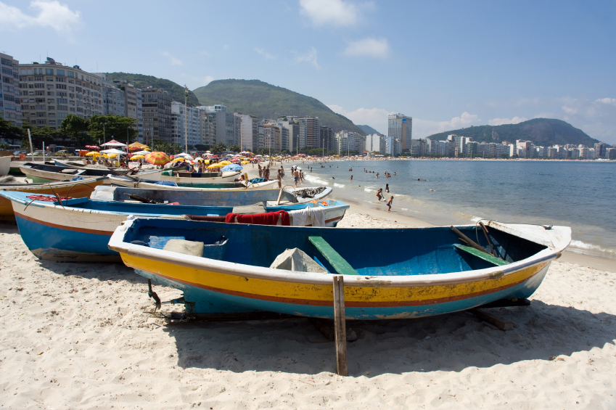
Year 1 | New Beginnings  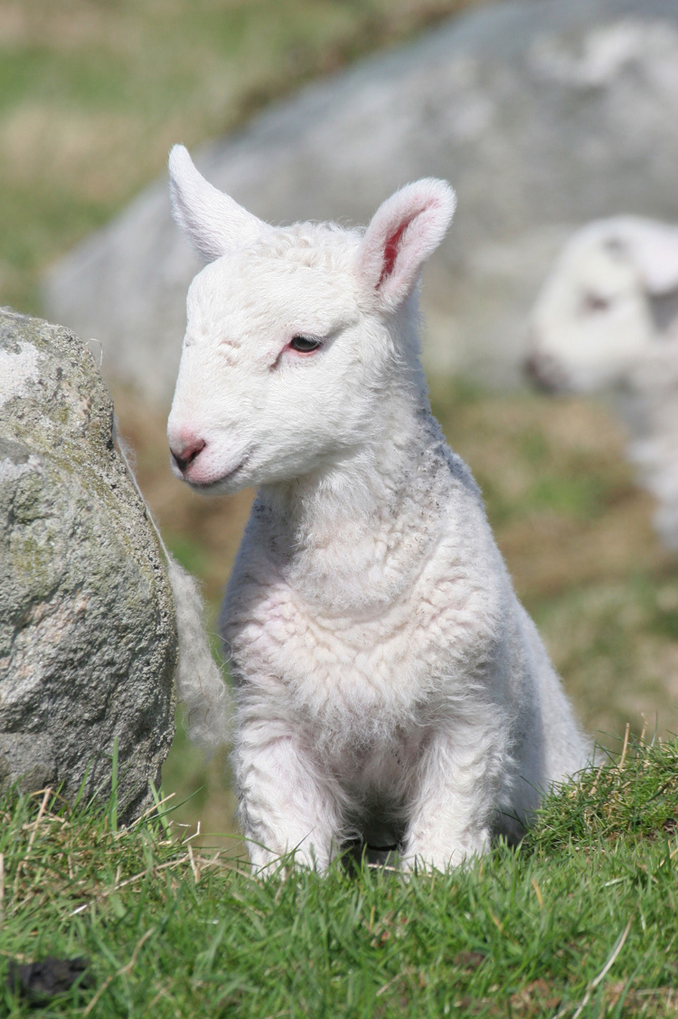  Ready Steady Cook   | Dressing Up | I’m Alive   | Once Upon a Time    100 Centenary | From Sea to Sea  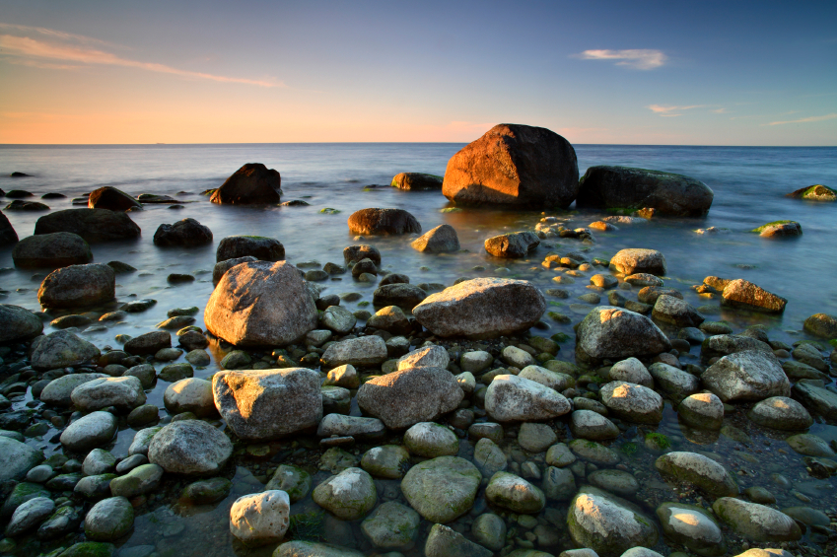 | 1,2,3 O’Leary  (Hastings Local Community)  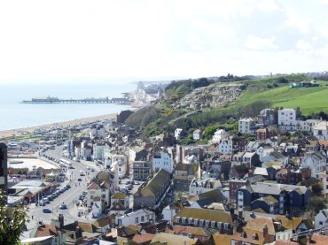
Year 2 | New Beginnings  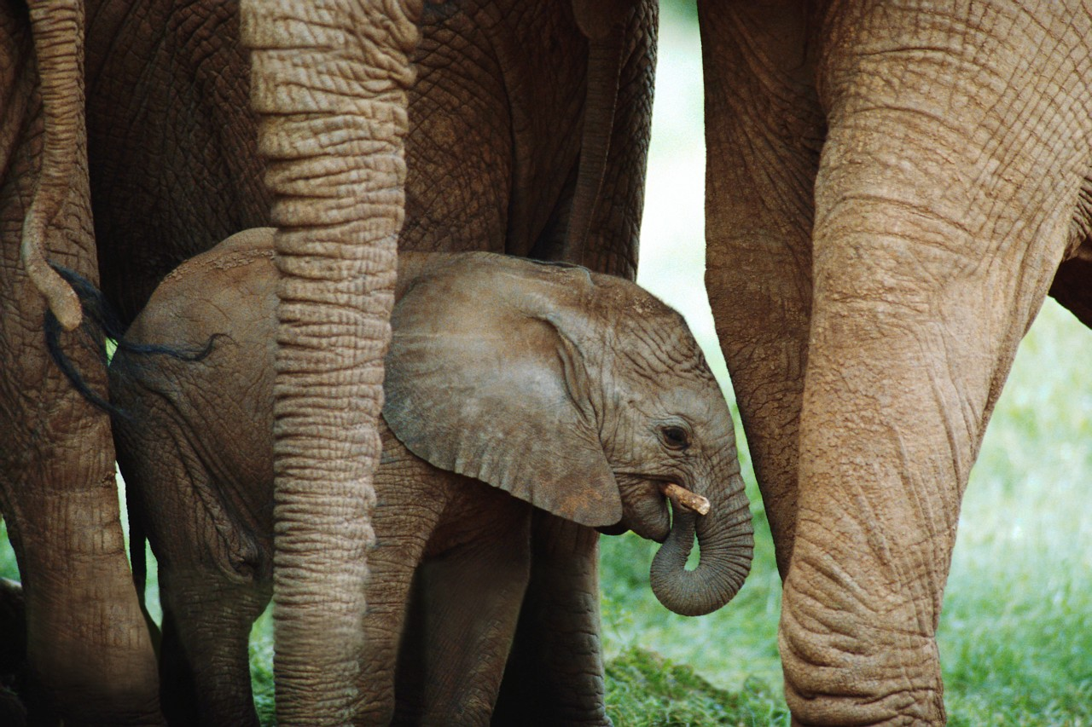  1066  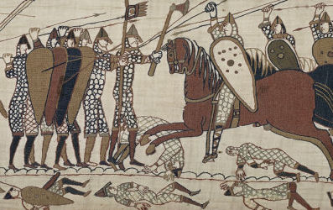 | Magical Moon    Christmas | Capturing Castles  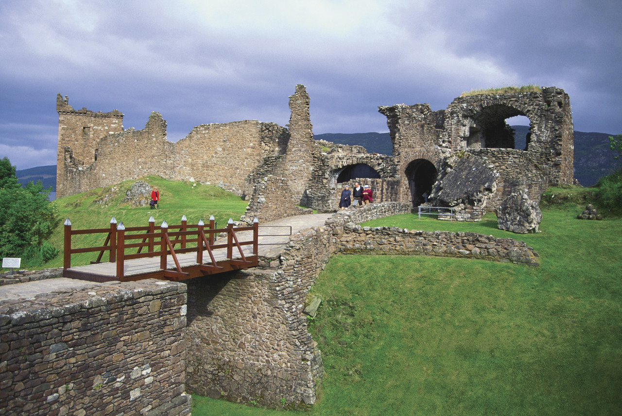 | 100 Centenary | Our World   | Hastings has talent  